Students can now freely access a selection of international OER sites
Added by Michael Paskevicius (Admin) on 20 Jul 2011
We are delighted to announce that UCT students can now access a selection of open educational resource sites without it impacting upon their student internet quota. We believe that the availability of educational resources from other institutions may enhance the student experience here at UCT. Scholarly resources such as open educational resources are increasingly becoming part of the valuable collection of resources students can use to assist their learning.
We believe that making these resources available to UCT students may increase the quality of teaching and learning at UCT, and demonstrate to students that we are committed to open education and knowledge sharing globally.
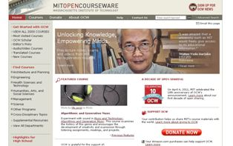 | MIT OpenCourseWare (OCW) is a web-based publication of virtually all MIT course content. OCW is open and available to the world and is a permanent MIT activity.  http://ocw.mit.edu
 | The Johns Hopkins Bloomberg School of Public Health's OPENCOURSEWARE (OCW) project provides access to content of the School's most popular courses. As challenges to the world's health escalate daily, the School feels a moral imperative to provide equal and open access to information and knowledge about the obstacles to the public's health and their potential solutions.  http://ocw.jhsph.edu
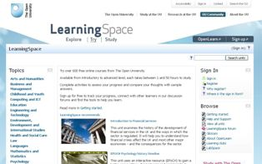 | OpenLearn gives you free access to learning materials from The Open University. In the first two years, OpenLearn grew to include over 8000 study hours of learning materials from Open University courses. The website continues to grow with new course materials being published regularly in their LearningSpace.  http://openlearn.open.ac.uk
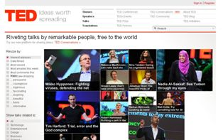 | TED is a nonprofit organisation devoted to Ideas Worth Spreading. It started out (in 1984) as a conference bringing together people from three worlds: Technology, Entertainment, Design. Since then its scope has become ever broader.  http://www.ted.com/talks
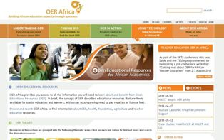 | OER Africa is an innovative initiative established by the South African Institute for Distance Education (Saide) to play a leading role in driving the development and use of Open Educational Resources (OER) across all education sectors on the African continent.  http://www.oerafrica.org
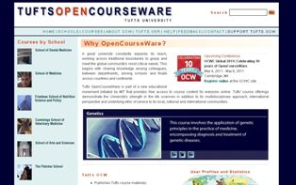 | Tufts University is committed to offering the world's learners free access to its many academic resources. Tufts OpenCourseWare (OCW) seeks to capitalize on the potential of the internet to eliminate borders and geographic distance as obstacles to the instantaneous exchange of knowledge and new ideas.  http://ocw.tufts.edu

