Errata – “Identifying Binding Constraints in Education”

Authors: Servaas van der Berg, Nicholas Spaull, Gabrielle Wills, Martin Gustafsson & Janeli Kotze

31 May 2016

The following errors and corrections relate to the report “Identiyfing Binding Constraints in Education” Released by RESEP on the 23rd of May at the following address - http://resep.sun.ac.za/index.php/resep-launches-two-reports-on-education/

- [Page 5] The text “60% of South African children do not learn to read for meaning in any language by the end of grade 3” should read “58% of South African children do not learn to read for meaning in any language by the end of grade 4”
- [Page 9] The sentence beginning “The NSES study of 2007-2009…less” should read “The 2007-2009 NSES study of numeracy and literacy across 8 of 9 provinces (Gauteng excluded) showed that most Grade 5 children write in their language books only once per week or less.”
- [Page 14; 16] the term illiterate used here and throughout the report should be “reading illiterate” not “illiterate”
- [Page 15] The sentence “As we will show below, approximately 60% of South African children do not learn to read in any language (including their home languages) by the end of grade 4” should read “As we will show below, approximately 60% of South African children do not learn to read for meaning in any language (including their home languages) by the end of grade 4”
- [Page 15] The reference “by the end of Grade 3 (Spaull, 2015)” in the second to last paragraph should be “by the end of Grade 4 (Spaull, 2015)”
- [Page 20] In an earlier version of the report Figure 5 is incorrect and has the wrong labels for the wrong bars in the bar chart. The correct chart is as follows:

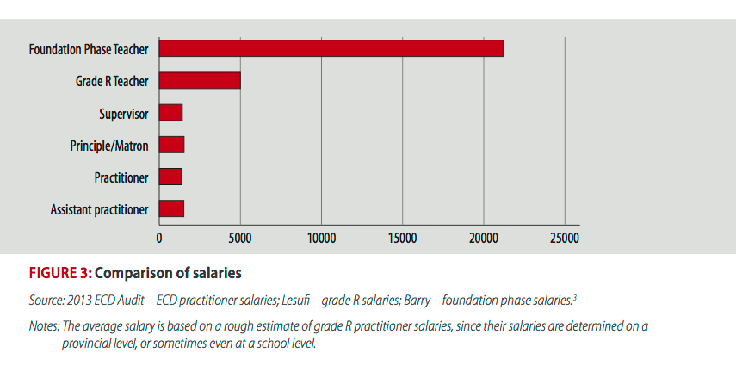

- [Page 43] The pop-out should read “71% of teachers were women, but only 36% of teachers were women”, i.e. this refers to all teachers and principals not just primary school principals and teachers.

